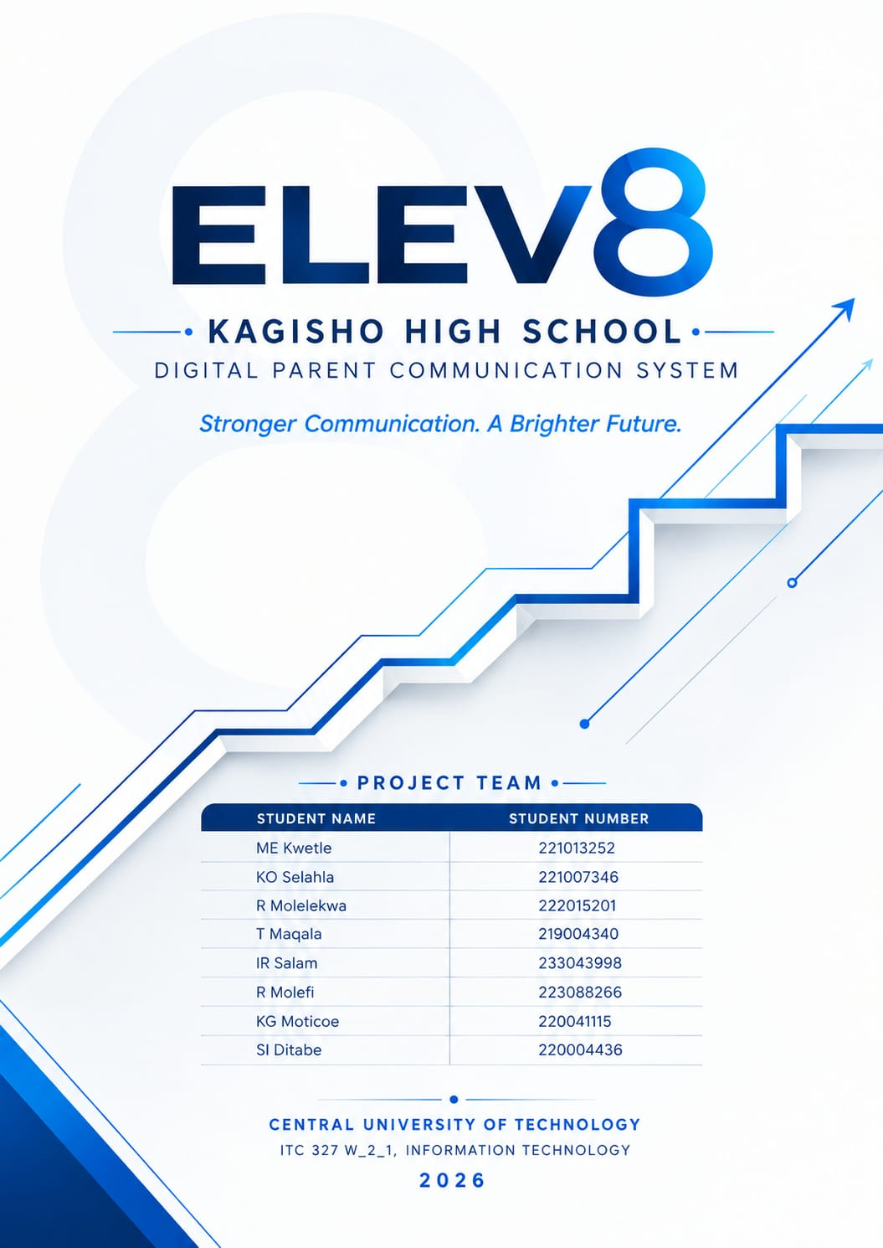

Table of Contents
Table of Contents 2
1. Project Introduction 4
2. Stakeholder and Organisation Profile 4
2.1 Organisation and Stakeholder 4
2.2 Key Stakeholders 4
3. Current Process. 5
3.1 Current Process Challenges 5
4. Problem Statement 5
5. Project Aim and Objectives 5
5.1 Aim 5
5.2 Objectives 5
6. Project Scope 6
6.1 Deliverables (In Scope) 6
6.2 Acceptance Criteria 6
6.3 Constraints 6
6.4 Assumptions 6
7. Stakeholder Needs. 7
8. Stakeholders and User Groups 7
9. Functional Requirements 8
10. Non-Functional Requirements 8
11. Flutter Requirements 8
12. ASP.NET Requirements 9
13. Supabase and Integration Requirements 9
13.1 Supabase Requirements 9
13.2 Integration Requirements 9
14. Feasibility Study 10
14.1 Technical Feasibility 10
14.2 Operational Feasibility 10
14.3 Economic Feasibility 10
14.4 Schedule Feasibility 10
14.5 Legal Feasibility 10
14.6 Ethical Feasibility 11
14.7 Overall Feasibility Conclusion 11
15. Project Risk Register 12
15.1 Three Highest-Priority Risks 13
16. Requirements Change Log 13
17. Refined Project Scope 13
18. Relevant Stakeholder Evidence 14
18.1 Stakeholder Representative 14
18.2 Evidence Handling 14
19. System Technologies 15
19.1 Flutter Application 15
19.2 ASP.NET Backend 15
19.3 Supabase Database 15
20. Importance / Benefits 15
20.1 For Kagisho High School 15
20.2 For Parents/Guardians 15
20.3 For Learners 16
21. Conclusion 16
Appendix A – Requirements Coverage Checklist 17
Final Project Position 18

1. Project Introduction
Kagisho High School is a school located in Bloemfontein with close to 2000 students. The purpose of our project is to find an existing issue within a business and find a solution for it. The school currently sends home paper-based letters/notices/information with learners as a way to communicate important information to parents.
Our proposed solution to the issue Kagisho High School is facing is a digital communication system consisting of a school web portal and a Flutter-based mobile application for parents/guardians. The school will be able to publish announcements and upload important documents through the web portal, and parents will access these announcements and documents directly through the mobile application.

2. Stakeholder and Organisation Profile

2.1 Organisation and Stakeholder
Item | Description
Primary Stakeholder | Kagisho High School — we have identified the communication issue and our proposed solution is being developed for this organisation.
Stakeholder Representative | Principal Motoneshe
Current Users Affected | Principal/School Management, School Administrative Staff, Parents/Guardians, and Learners (indirectly, as current message carriers).

2.2 Key Stakeholders
The following stakeholder groups were identified in the original project analysis:

Principal / School Management
- Interested in improving communication with parents.
- May oversee the publication of important information.

School Administrative Staff
- May operate the web portal.
- Upload and manage announcements and documents.

Parents / Guardians
- Main users of the Flutter application.
- Need reliable access to school information.

Learners
- Indirectly affected because they currently play a role in carrying information between school and home.

Pricinpal Motoneshe from Kagisho Secondary School
18 September 2026 – Recorded Interview
Stakeholder Interview.mp4

3. Current Process.
Step | Current Activity | Person Involved
1 | School prepares an important letter, notice, or piece of information for parents. | School staff / management
2 | The paper-based letter is given to the learner to take home. | School staff, learner
3 | The learner is expected to hand the letter to their parent/guardian. | Learner
4 | The parent/guardian receives the information, if the letter reaches them. | Parent/guardian
5 | The parent attends or responds to the school communication, if received. | Parent/guardian

3.1 Current Process Challenges
As identified in the original project analysis:
- Students fail, lose, or forget to give parents these letters.
- Parents tend to miss meetings, events, or other school activities as a result.
- The school has a very limited ability to ensure that parents do indeed receive the information.
The main issue is therefore the communication gap between the parents and the school — specifically, that Steps 2 and 3 above frequently fail, breaking the chain of information before it reaches the parent.

4. Problem Statement
Important information gets sent home as paper-based letters, and students are expected to give their parents these letters. However, it has come to the school's attention that most students fail, lose, or forget about these communications.
As a result, parents tend to miss meetings, events, or any other school activities. The school has a very limited ability to ensure that parents do indeed receive the information. Our main problem is therefore the communication gap between the parents and the school.

5. Project Aim and Objectives

5.1 Aim
Our aim is to design and develop a digital communication system that improves communication between Kagisho High School and parents/guardians, by providing a centralised web portal for school staff and a Flutter-based mobile application for parents, reducing the school's reliance on learners to physically deliver notices.

5.2 Objectives
- To improve communication between Kagisho High School and parents/guardians.
- To provide parents with direct access to important school announcements.
- To reduce the school's reliance on learners delivering physical notices.
- To provide school staff with a centralised platform for publishing information.
- To provide a secure and accessible digital communication platform.

6. Project Scope

6.1 Deliverables (In Scope)
Within Scope | Outside of Scope
School web portal | Online school fee payments
Flutter parent mobile application | Learner marks/report management
Parent registration/login | Online examinations
Staff authentication | School transport management
Announcement creation | Full learner attendance management
Announcement management | Parent-to-parent communication
Uploading school letters/documents | Social-media/chat functionality
Viewing announcements | Complete school administration management
Accessing documents
Notifications
Database integration

6.2 Acceptance Criteria
- A staff member can log into the web portal and publish an announcement with a title, description, category, date, and target audience.
- A parent/guardian can register, log in, and view announcements relevant to their child's grade within the mobile application.
- An uploaded school letter/document can be attached to an announcement and successfully opened by a parent through the mobile application.
- A parent receives a notification when a new, important announcement is published.
- Data entered or published via the web portal is available to the parent application through the shared backend within [XX] seconds.

6.3 Constraints
- The prototype must be built using Flutter (mobile), ASP.NET (backend/web) and Supabase (database), as required by the module.
- Development must be completed within the ITC327W semester timeline.
- Only fictional, anonymised, or test data may be used for parents, learners, and announcements during development and demonstration, given that real learner/parent data is personal information.
- The system itself will not be responsible for physically scanning documents — staff must convert physical letters to digital format (e.g. PDF or image) before upload.

6.4 Assumptions
- The stakeholder (Kagisho High School) will remain available for feedback and validation throughout all three phases.
- Parents/guardians have access to a smartphone and basic internet connectivity to use the mobile application.
- School administrative staff will be available and willing to convert and upload physical letters as part of their existing workflow.
- Group members have, or will acquire, sufficient skill in Flutter, ASP.NET, and Supabase within the project timeline.

7. Stakeholder Needs.
Stakeholder Need (to be confirmed) | Source / Evidence
A reliable way to ensure parents receive important information | 18 September 2026
Reduced dependence on learners to deliver physical letters | 18 September
Ability to send specific information to targeted grades. | 18 September

8. Stakeholders and User Groups
Stakeholder / User Group | Role in the Project or System
Kagisho High School | External stakeholder whose communication problem is being addressed.
Principal / School Management | Interested in improving communication with parents; may oversee publication of important information.
School Administrative Staff | Operate the web portal; upload and manage announcements and documents.
Parents / Guardians | Main users of the Flutter application; need reliable access to school information.
Learners | Indirectly affected; currently responsible for carrying information between school and home.
Group ELEV8 | Student development team responsible for requirements, design, development, testing and documentation.

9. Functional Requirements
ID | Requirement
FR1 | The system will allow authorised school staff to log into the web portal.
FR2 | The system will allow authorised staff to create and publish announcements.
FR3 | The system shall allow staff to upload relevant school documents and letters.
FR4 | The system will let staff edit or remove published announcements.
FR5 | The Flutter application will allow parents/guardians to register and log in.
FR6 | Parents/guardians will be able to view school announcements from the application.
FR7 | The application will allow parents/guardians to access uploaded school documents.
FR8 | Notifications will be provided for important announcement by system.
FR9 | The system will store announcement and user information securely.
FR10 | Information published by authorised staff will become accessible to the intended parent users.

10. Non-Functional Requirements
ID | Category | Requirement
NFR01 | Security | Only authorised users should be able to access certain system functions.
NFR02 | Usability | The Flutter application should be simple and easy for parents with different levels of technological experience to use.
NFR03 | Performance | Announcements and documents should load within a reasonable amount of time.
NFR04 | Reliability | Information published by the school should be stored accurately and remain accessible.
NFR05 | Availability | Parents should be able to access important school information when needed.
NFR06 | Maintainability | The system should be designed so that it can be maintained and improved in the future.

11. Flutter Requirements
- The Flutter application shall allow parents/guardians to register and log into their accounts.
- It shall provide access to the application's home/dashboard.
- It shall allow parents to view school announcements, including those relevant to their child's grade.
- It shall allow parents to open and access attached school letters/documents.
- It shall provide notifications when important information is published.
- It shall allow parents to view previously published announcements.
- It shall allow parents to log out securely.
- It must use the shared backend so that information remains consistent with the web portal.

12. ASP.NET Requirements
- The ASP.NET backend shall handle requests from the mobile application.
- It shall support authorised staff authentication for the web portal.
- It shall support creation, editing, and removal of announcements, including title, description, category, date, priority, and target audience.
- It shall support uploading and attaching digital school letters/documents to announcements.
- It shall support user-related operations (staff and parent accounts).
- It shall handle communication with the Supabase database.
- It shall process and return information to the Flutter application.

13. Supabase and Integration Requirements

13.1 Supabase Requirements
Supabase will be used for data storage and database-related services, storing information such as:
- Parent/guardian accounts
- User information
- Announcements
- School documents
- Dates and other relevant system information

13.2 Integration Requirements
Integration ID | Requirement
INT01 | The Flutter application and the ASP.NET backend shall communicate through a defined set of API requests.
INT02 | The ASP.NET backend and Flutter application shall both connect to the same Supabase project (database and storage), ensuring a single source of truth.
INT03 | An announcement or document published through the web portal shall become available to the Flutter application without manual synchronisation.
INT04 | User authentication (staff and parent accounts) shall be managed consistently through the shared backend.
INT05 | Integration testing shall check connectivity, login, and cross-application data sharing between the web portal and the mobile application.
Integration architecture: Flutter mobile application → ASP.NET backend → Supabase database/storage ← School Web Portal.

14. Feasibility Study

14.1 Technical Feasibility
The project is technically feasible because the required technology stack (Flutter, ASP.NET, Supabase) is defined by the module and is well suited to a communication/announcement system of this scale. The main technical challenges are integrating the three technologies, implementing reliable notifications, and ensuring uploaded documents remain accessible and correctly linked to announcements.

Conclusion: Feasible, provided integration and notification functionality are tested early.

14.2 Operational Feasibility
The project is operationally feasible because it addresses a real, confirmed pain point (letters not reaching parents) with a solution that fits naturally into existing school communication habits. The main operational consideration is parent digital literacy and device access, since parents have varying levels of comfort with mobile apps.

Conclusion: Feasible, provided the mobile application remains simple and staff receive basic on boarding on the web portal.

14.3 Economic Feasibility
As an academic prototype, the project relies primarily on free-tier tools: Flutter and ASP.NET are free frameworks, and Supabase offers a free tier suitable for this scale. The main resources required are group members' time, personal computing devices, and internet access, all already available to the group.

Conclusion: Economically feasible for a prototype; note that Supabase free-tier storage limits could matter if many documents/attachments are uploaded during testing.

14.4 Schedule Feasibility
The project must move from planning and requirements through system design, development, integration, testing, and final presentation within the ITC327W semester. Given the number of features described (staff publishing workflow, parent registration/login, document attachment and access, notifications), the group should prioritise the core communication loop first (publish → store → notify → view → access document) and treat features such as read/open-status tracking as secondary.

Conclusion: Feasible with changes — recommend an MVP of staff login, announcement publishing with attachment, parent login, and viewing/accessing announcements, with notifications and open-status tracking as secondary priorities.

14.5 Legal Feasibility
- Only fictional, anonymised, or test data shall be used for parent, learner, and announcement records during development and demonstration, no real learner or parent personal information will be used.
- Access to the web portal and any parent/learner data shall be restricted to authorised staff through login-based access control.
- Passwords, API keys, and Supabase service-role keys shall never be committed to GitHub.

14.6 Ethical Feasibility
- The stakeholder has been informed (or will be informed) that this is an educational prototype, not a production system.
- The group will be transparent about the prototype's current limitations and will not present it as fully deployment-ready.
- Given that the underlying real-world users include children's guardians and, indirectly, the children themselves, particular care will be taken not to use any real learner names, grades, or contact details in any demonstration.

Conclusion: Feasible, provided stakeholder consent, transparency, and strict use of anonymised/fictional data are maintained throughout.

14.7 Overall Feasibility Conclusion
Overall, the Kagisho High School Digital Parent Communication System is assessed as FEASIBLE WITH CONTROLLED CHANGES. The technology stack is appropriate and low-cost, the problem is clearly evidenced by the school's own observation that letters are frequently lost, and the solution directly targets the point of failure (physical, learner-mediated delivery). The main adjustments required are: (1) prioritising the core publish-to-access workflow as the MVP, (2) treating notifications and open-status tracking as secondary features, and (3) applying strict data-handling discipline given that the system touches parent and, indirectly, learner information.

15. Project Risk
ID | Risk Statement | Category | Likelihood | Impact | Score/Level | Mitigation
R01 | Group members lack sufficient Flutter/ASP.NET/Supabase experience, delaying development. | Technical | High | High | High (9) | Allocate early self-study time; use official documentation and tutorials from Week 5.
R02 | Stakeholder (Kagisho High School) becomes unavailable or unresponsive during a critical feedback period. | Stakeholder | Medium | High | High (6) | Schedule recurring check-ins in advance; confirm requirements in writing after each engagement.
R03 | Notifications fail to reach parents reliably (a core value proposition of the system). | Technical | Medium | High | High (6) | Test notification delivery early and across multiple devices; have a fallback (e.g. in-app announcement list) if push notifications are unreliable.
R04 | Parents have limited smartphone access or digital literacy, reducing adoption of the mobile app. | Operational | Medium | Medium | Medium (4) | Confirm typical parent device/internet access with the stakeholder; keep the app interface as simple as possible.
R05 | Real or sensitive parent/learner information is accidentally used in development or demonstration. | Legal/Ethical | Low | High | Medium (5) | Use only anonymised/fictional test data throughout; review all demo data before presentations.
R06 | Scope creep: additional features are requested beyond the agreed scope. | Scope | Medium | Medium | Medium (4) | Log all new requests in the Requirements Change Log; confirm changes with the stakeholder before implementing.
R07 | Data synchronisation issues arise between the Flutter app, ASP.NET backend, and Supabase. | Technical | Medium | High | High (6) | Design and test the Supabase schema and API contracts early; test integration continuously rather than only at the end.
R08 | Project schedule slips due to underestimating integration and testing effort. | Schedule | Medium | High | High (6) | Build schedule buffer around integration/testing; prioritise the core MVP workflow first.
R09 | Confidential information or credentials are accidentally committed to GitHub. | Security | Low | High | Medium (3) | Use environment variables and a .gitignore for all keys; review commits before pushing.
R10 | Uneven group member contribution affects project quality and timelines. | Team/Org. | Medium | Medium | Medium (4) | Use Microsoft Project and GitHub to track individual tasks; raise concerns with the lecturer early if unresolved.

15.1 Three Highest-Priority Risks
- R01 – Insufficient Flutter/ASP.NET/Supabase experience within the group (High).
- R03 – Notification delivery reliability, since this is central to the value proposition (High).
- R07 – Data synchronisation issues between the mobile app, backend, and Supabase (High).

16. Requirements Change Log
Version | Requirement/Scope Change | Reason | Decision
V1.0 | Broad school-communication concept | Initial stakeholder problem identification | Proposed
V1.1 | Online fee payments, marks/report management, online examinations, transport management excluded | Keep scope focused on the communication gap rather than broader school administration | Deferred/Excluded
V1.2 | Full learner attendance management, parent-to-parent communication, and social-media/chat functionality excluded | Reduce schedule and complexity risk; not part of the core communication problem | Deferred/Excluded
V1.3 | Notifications and document attachment confirmed as core features | Directly addresses the stakeholder's core problem (missed information) | Included

17. Refined Project Scope
Following the feasibility and risk analysis in Sections 14–15, the scope carried forward into system design is:

Core (must be delivered)
- Staff authentication and web portal access
- Announcement creation, editing, and removal
- Document upload and attachment to announcements
- Parent registration and login
- Viewing announcements and accessing attached documents on the mobile app
- Shared Supabase backend integration between web portal and mobile app

Supporting (delivered if time permits)
- Push notifications for important announcements
- Staff visibility into whether parents have opened an announcement
- Audience targeting by grade and priority levels on announcements

18. Relevant Stakeholder Evidence
Evidence | What Should Be Included
Stakeholder meeting | Date, attendees, purpose, problems discussed, requirements identified, and decisions made.
Requirement confirmation | Evidence that the stakeholder confirmed the identified requirements.
Scope confirmation | Evidence that the proposed solution addresses the stakeholder's problem.
Follow-up communication | Relevant email, Teams, or WhatsApp communication where applicable.
Current-process evidence | Any appropriate evidence demonstrating how letters are currently distributed and where they get lost.

18.1 Stakeholder Representative
Name/designation: Principal Motoneshe
Date of stakeholder engagement: 18 SEPTEMBER 2026
Evidence reference/appendix number:

18.2 Evidence Handling
- Do not include unnecessary personal information, especially regarding learners (minors).
- Do not attach confidential documents unless approved and required.
- Do not include passwords, private keys, or other credentials.
- Anonymise evidence where necessary.
- Use fictional, anonymised, or test data for all prototype demonstrations.

19. System Technologies

19.1 Flutter Application
Flutter will be used to develop the parent-facing mobile application. It will provide the interface through which parents/guardians can:
- Log in
- View announcements
- Access documents
- Receive important updates
- Interact with the system from their mobile devices

19.2 ASP.NET Backend
ASP.NET will provide the backend services that allow the different parts of the system to communicate. It will handle things such as:
- Requests from the mobile application
- User-related operations
- Announcement-related operations
- Communication with the database
- Processing and returning information to the application

19.3 Supabase Database
Supabase will be used for data storage and database-related services. It can store information such as:
- Parent/guardian accounts
- User information
- Announcements
- School documents
- Dates and other relevant system information

20. Importance / Benefits

20.1 For Kagisho High School
- Improves communication with parents.
- Provides a central place for school announcements.
- Reduces reliance on physical letters.
- Makes publishing information easier.
- Provides a more organised communication process.

20.2 For Parents/Guardians
- Direct access to school information.
- Less dependence on learners bringing letters home.
- Easier access to important announcements.
- Ability to view information from their mobile device.
- Reduced likelihood of missing important school notices.

20.3 For Learners
- Reduces their responsibility for delivering important school communications.
- Helps ensure their parents receive information directly.

21. Conclusion
As ELEV8, we identified a communication gap at Kagisho High School where important announcements, letters and notices may not always reach parents when they are sent home through learners. Our proposed solution is a digital communication system consisting of a school web portal and a Flutter mobile application for parents and guardians
The system will allow school staff to publish announcements and upload important documents, while parents can access this information directly through the application and receive notifications. Using Flutter, ASP.NET and Supabase, our aim is to provide Kagisho High School with a more reliable, organised and accessible way of communicating with parents.

Appendix A – Requirements Coverage Checklist
No. | Required Area | Location in Document | Status
1 | Stakeholder and organisation profile | Section 2 | Included (representative TBC)
2 | Current process | Section 3 | Added
3 | Problem statement | Section 4 | Included (original)
4 | Project aim and objectives | Section 5 | Aim added; objectives original
5 | Project scope (incl. acceptance criteria, constraints, assumptions) | Section 6 | Scope original; rest added
6 | Stakeholder needs | Section 7 | Added – pending evidence
7 | Stakeholders and user groups | Section 8 | Included (original)
8 | Functional requirements | Section 9 | Included (original) – gaps flagged
9 | Non-functional requirements | Section 10 | Included (original) + IDs added
10 | Flutter requirements | Section 11 | Added (derived from original)
11 | ASP.NET requirements | Section 12 | Added (derived from original)
12 | Supabase and integration requirements | Section 13 | Supabase original; integration added
13 | Feasibility study (all 6 areas + conclusion) | Section 14 | Added in full
14 | Project risk register | Section 15 | Added in full
15 | Requirements change log | Section 16 | Added in full
16 | Refined project scope | Section 17 | Added in full
17 | Relevant stakeholder evidence | Section 18 | Added – pending evidence

Final Project Position
Area | Current Position
Project | Kagisho High School Digital Parent Communication System
Problem | Paper-based letters/notices frequently fail to reach parents, causing missed meetings, events, and school activities.
Gap | No reliable, direct, traceable communication channel between the school and parents that does not depend on learners physically delivering letters.
Solution | Integrated Flutter (parent) + ASP.NET (backend) + Supabase (database) system, with a school web portal for staff.
Core improvement | Direct, reliable, notification-driven communication that reduces reliance on physical, learner-mediated delivery.
Feasibility | Feasible with controlled changes (draft – confirm with group).
Next phase | System architecture and design — pending stakeholder evidence and requirements confirmation.

PHASE 2

Github Repository Link :

https://github.com/kilogr4m/Kagisho-High-School-Parent-Communication-System-.git

PrOGRESS TRACKER: MS PROJECT:

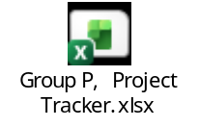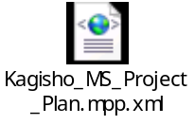

System Architecture Link :



https://lucid.app/lucidchart/98fc20a2-fbe7-41ed-85cf-18fc5d3572d0/edit?viewport_loc=-1990%2C-2359%2C1655%2C2431%2C0_0&invitationId=inv_2dec9824-1650-462b-bd89-6ffd7a1a7445

ENTITY RELATIONSHIP DIAGRAM LINK:



https://lucid.app/lucidchart/65c8d2e5-ffc8-481b-98c9-dc5e647d9117/edit?view_items=kB9AEwguMK6k&page=0_0&invitationId=inv_4c037408-aa35-42bc-bbcb-e22c55f19fd0

Figma Prototype links:

https://www.figma.com/design/0ls1mjqplfspCbg3k1MOob/Kagisho-Connect-%E2%80%A2-Parent-App---School-Portal?node-id=0-1&t=0TMKqEnxMTAm2FU9-1

Sequence Diagrams:


https://lucid.app/lucidchart/6c5abb7e-0fb1-47ff-b69f-75e9599215b5/edit?viewport_loc=-161%2C-1459%2C1264%2C1856%2C0_0&invitationId=inv_1b1866b0-f65b-468e-ba82-f94a9228d918

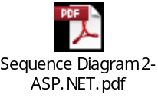
https://lucid.app/lucidchart/7605e4f2-7aee-4722-8205-a842ccbeab9c/edit?viewport_loc=-180%2C-423%2C1295%2C1902%2C0_0&invitationId=inv_73cc681a-e3e0-4006-8bf5-2581c44c1585

USE CASE DIAGRAM:

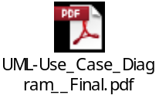
https://lucid.app/lucidchart/75d69d49-aeb0-4a5b-9289-0cf094157f2f/edit?viewport_loc=-60%2C-513%2C1169%2C1718%2C0_0&invitationId=inv_a9d111bd-2c0b-4f14-a301-3e328e1d978c

